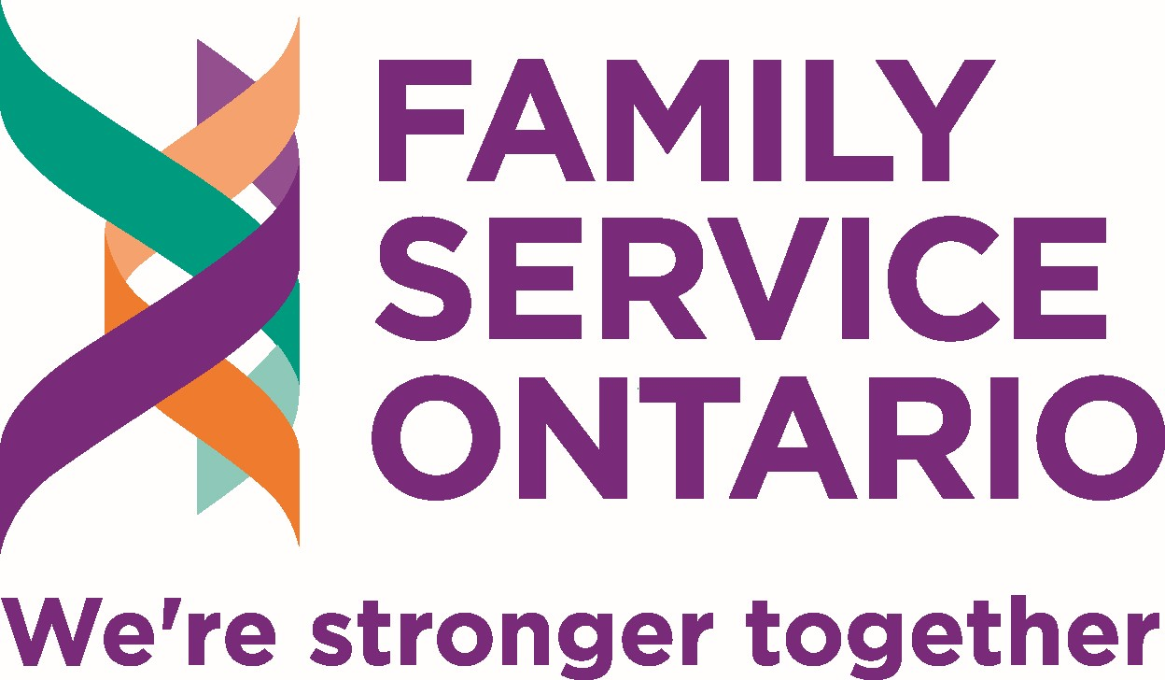

The Opportunity
Family Service Ontario is seeking an exceptional Executive Assistant to work closely with the Chief Executive Officer and help turn priorities into well-organized action. This is a high-trust role for someone who combines excellent executive support with strong writing, creative communications, project coordination, research, event delivery, problem-solving, and confident use of technology.
Your work will help FSO support agencies that deliver vital services to individuals and families across Ontario. By strengthening the CEO’s effectiveness, helping organize events, and producing high-quality communications, you will contribute directly to a stronger, better-connected family-service sector.

About Family Service Ontario
Family Service Ontario champions individual, family, and community well-being through advocacy, resources, expertise, and policy support. FSO connects family service agencies with policymakers, funders, partners, and one another to strengthen capacity and create sustainable solutions across Ontario.
We offer an outstanding, collaborative workplace culture grounded in strong values and our shared belief that we are stronger together. We value initiative, thoughtful problem-solving, creativity, accountability, inclusion, and high-quality work.

What You Will Do

Support the CEO and organizational governance
- Manage scheduling, priorities, travel arrangements, and follow-up with a high degree of discretion.
- Coordinate board and regional member events, including scheduling, agendas, meeting packages, minutes, action tracking, logistics, and communications.
- Prepare invoices for membership, conference, training, and other fees, and accurately track invoices, payments, outstanding balances, and required follow-up.
- Anticipate needs, protect confidential information, and ensure commitments and decisions do not get lost between meetings.

Coordinate projects and events
- Build practical work plans, track timelines and deliverables, coordinate contributors, and flag risks or decisions requiring attention.
- Support the CEO in organizing training, special events, and the annual conference held in Toronto, in collaboration with Board committees, which includes securing speakers, venues, and sponsors.
- Coordinate registration, schedules, communications, materials, logistics, accessibility arrangements, and post-event follow-up.

Research, write, and create
- Conduct focused research and help the CEO turn the findings into clear briefings, summaries, resources, proposals, or communications.
- Draft social media posts, posters, event promotions, surveys, and other public-facing materials.
- Edit professional correspondence, briefings, and reports created by the CEO.
- Use Canva to produce polished, accessible, brand-consistent communications for members, partners, and the public.

Use technology to improve the work
- Use Microsoft 365 and other digital platforms confidently for collaboration, scheduling, documents, projects, surveys, events, and communications.
- Use approved AI tools at a practical working level, verify outputs carefully, protect confidential information, and continue building your AI capability.
- Identify better ways to organize recurring work, document processes, and reduce avoidable administrative burden.

What You Bring

Essential qualifications
- Excellent writing, editing, verbal communication, and interpersonal skills.
- Experience providing senior-level executive or administrative support, including scheduling, correspondence, meeting preparation, minutes, and action tracking.
- Experience coordinating projects and special events.
- Proficiency with Canva and the ability to create engaging social media content, posters, presentations, and other public-facing materials.
- Strong research skills and the ability to assess sources, synthesize information, and communicate findings clearly.
- Strong organizational skills, sound judgment, and the ability to manage competing priorities and deadlines.
- Comfort with technology, including Microsoft 365, and practical familiarity with AI tools combined with a willingness to keep learning.
- A proactive, solutions-focused approach. You take initiative, raise issues early, and follow work through to completion.
- Residence in Ontario with the ability to travel periodically within Ontario, for the annual conference in Toronto and occasional in-person meetings.

Education and experience
- Post-secondary education in a relevant field, or an equivalent combination of education and experience.
- We welcome transferable experience and will assess candidates on demonstrated ability to perform the work rather than on credentials alone.

Assets
- Experience in a nonprofit, membership association, family or social service organization.
- Experience supporting a board of directors, governance committee, or member network.
- Experience with websites, event-registration systems, social media scheduling, surveys, project-management tools, funding research, or proposal support.

Employment Details
Position | Permanent, full-time
Anticipated start date | January 4, 2027
Probationary period | Three months
Salary | $70,000 annually
Hours | 35 hours per week; with flexible scheduling to balance operational needs and individual preferences
Remote work arrangement and support | Fully remote within Ontario, with periodic travel for the annual conference held in Toronto and occasional in-person meetings across Ontario  Provided by FSO: Computer; required software; phone and internet costs  Provided by employee: A private home office/location
Paid time off | Two weeks of vacation (3 weeks at 2 years)  Paid December holiday shutdown  Two float/personal days annually  Generous sick leave, covering personal illness, family care, and medical appointments
Benefits | Full benefits program  Employer contribution of 3% to an RRSP
Use of AI in hiring | Artificial intelligence will not be used to screen or select applicants

How to Apply
Please email your resume and cover letter to fso@familyserviceontario.org by November 10, 2026. Use the subject line: Executive Assistant Application.
We appreciate the time and interest of all applicants. Only candidates selected for an interview will be contacted.

Equity, Inclusion, and Accessibility
Family Service Ontario is an equal opportunity employer committed to a respectful, inclusive, and accessible workplace. We welcome applications from qualified candidates with diverse identities, backgrounds, perspectives, abilities, and lived experiences. Employment decisions are based on the requirements of the position, and each candidate’s demonstrated qualifications and experience
Accommodation is available on request in accordance with the Ontario Human Rights Code and the Accessibility for Ontarians with Disabilities Act. Applicants who require accommodation may contact fso@familyserviceontario.org. Information related to accommodation will be treated confidentially.

